- Log into your HealthStream account
- Click on “Catalog”
- Search for “What a Pain-Recorded

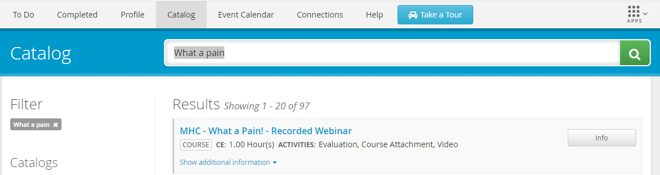

- Click on “Info”
- Click on “Enroll”
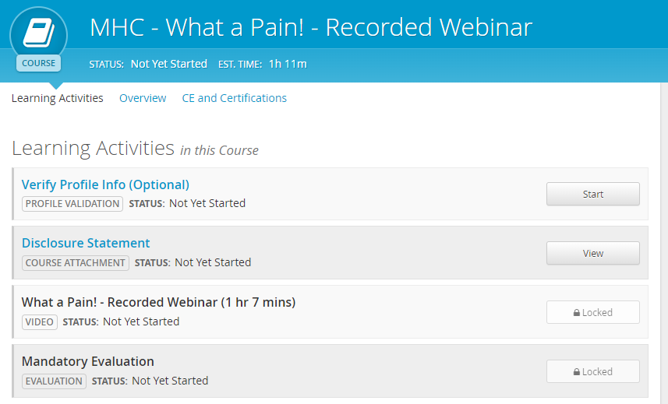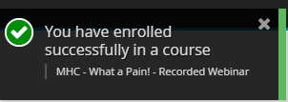
- You must read the disclosure statement, view the video, and fill out the mandatory evaluation to obtain your continuing education certificate.

- To see the CE Certificate, you have to click the title of the course from the Completed tab. Then, choose the CE and Certifications link:

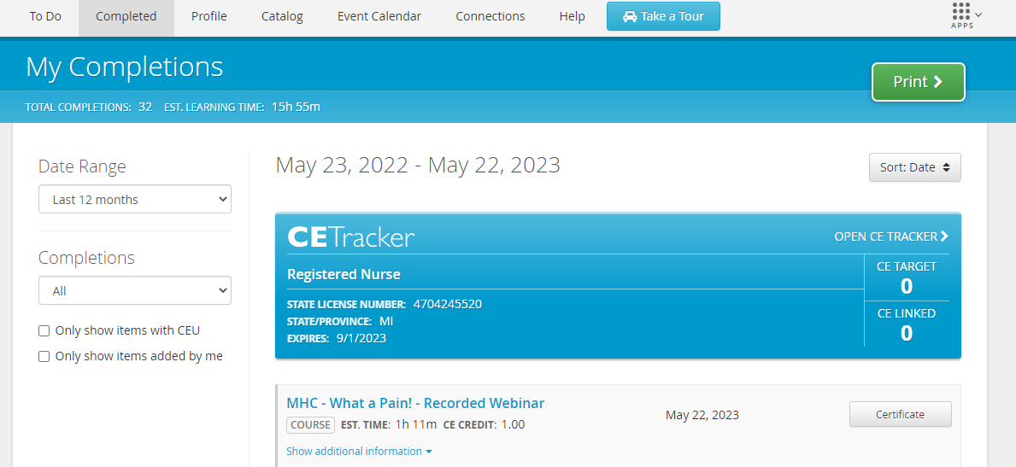

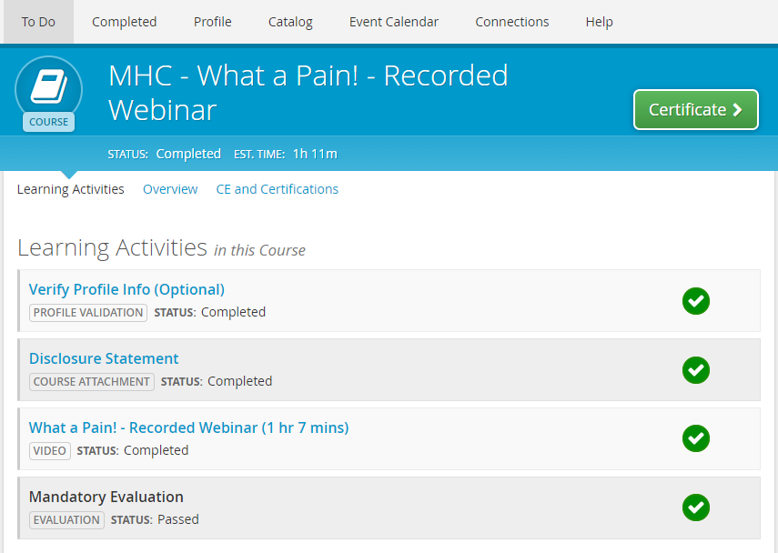

- Print off your continuing education certificate.

